Measurements of SAXS signal during TATB detonation using synchrotron radiation

Ten K. A.¹, Titov V. M.¹, Pruuel E. R.¹, Lukyanchikov L. A.¹, Tolochko B. P.², Zhogin I. L.², Aminov Yu. A.³, Filin V. P.³, Loboyko B. G.³, Muzyrya A. K.³, Smirnov E. B³

¹ Lavrentiev Institute of Hydrodynamics, Novosibirsk, Russia
² Institute of Solid State Chemistry and Mechanochemistry, Novosibirsk, Russia
³ Russian federal nuclear center, Sneginsk, Russia

Abstract. Small-angle X-ray scattering (SAXS) is investigated via registering the diffraction signal from a sample in the small-angle area. This method is widely used for analysis of the structure of disperse systems. Application of highly-periodic synchrotron radiation (SR) from the accelerator complex VEPP-3 to measuring SAXS with exhibition for 1 ns allows tracing development of the signal in the course of detonation of high explosives. Analysis of data obtained allows estimating the size of resulting particles of condensed carbon as well as particle size variations in time after the detonation wave has passed. Pressed charges of TATB (20 mm in diameter) were under study. Nanoparticles of d~2.2 nm are registered immediately after the detonation front. Then the particle size is increasing weakly and reaches the value d~2.6 nm by the instant t=4 μs. No traces of nanodiamonds bigger than 1 nm have been found in the products of TATB explosion.

Introduction

The problem of carbon condensation at detonation of oxygen-deficient high explosives is still open to question. It is important both for understanding the physics aspect of the phenomenon and for evaluation of the amount of energy released at exothermic coagulation of carbon clusters. Comparison of computational and experimental data on acceleration of thin metal plates by products of detonation of oxygen-deficient high explosives shows that such process is described with a better accuracy under an assumption of carbon condensation behind the chemical reaction zone, or as is the convention in the detonation theory, behind the Chapman-Jouget plane, which separates the reaction zone from the gas-dynamic flow of the explosion products [1, 2].
For the time being, sizes of condensed carbon nanoparticles at detonation of high explosives can be experimentally registered only through diffraction methods using synchrotron radiation (SR) [3, 4].
Application of highly-periodic synchrotron radiation (SR) from the accelerator complex VEPP-3 (BINP SB RAS, Novosibirsk) to measuring SAXS makes it possible to trace the development of signal in the course of detonation of high explosives. Analysis of the development allows estimating the sizes of the resulting particles of condensed carbon as well as size variations in time after the detonation wave has passed.
Theory of SAXS
SAXS is an analytical method to determine the structure of particle systems in terms of averaged particle sizes or shapes. The materials can be solid or liquid and they can contain solid, liquid or gaseous domains (so-called particles) of the same or another material in any combination.
The scattering of one particle, which is made of many atoms, can be explained as the interference pattern produced by all the waves that are sent to the detector from every electron/atom inside the particle (fig. 1). Summing up all the wave amplitudes at the detector position and making the square of this sum results in an interference (scattering) pattern. This pattern oscillates in a fashion that is characteristic for the shape (or the form) of the particle. It is therefore called "the form factor". It is called a "factor", because it must be scaled with a constant in order to match the experimental intensity units.
In practical applications many particles are illuminated at the same time and the observed scattering pattern corresponds to the form factor only.
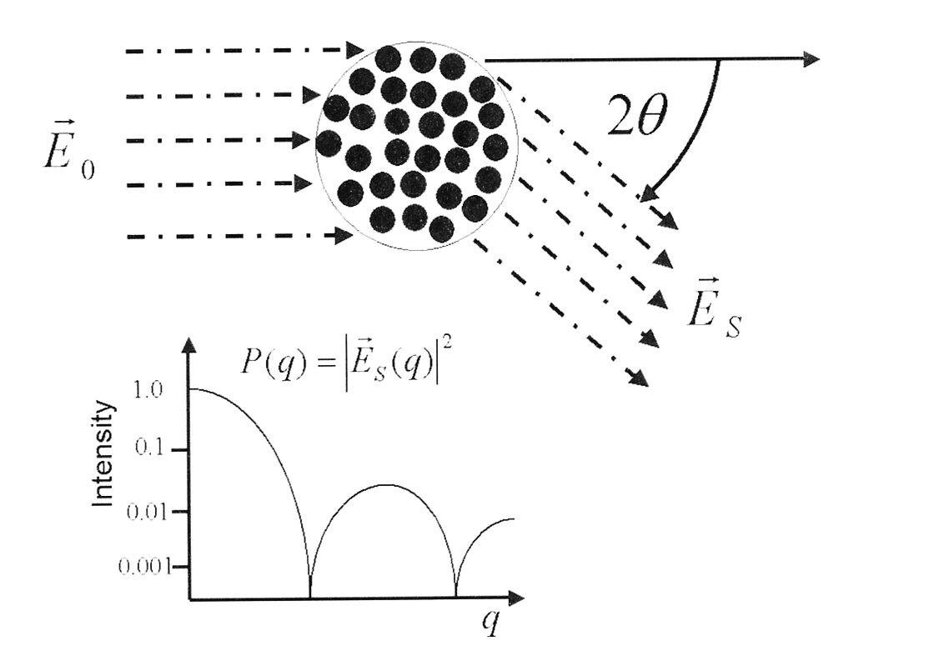
Fig.1. The form factor P(q) of a particle is an interference pattern, the oscillations of which are typical of the particle's shape. $q=4π⋅\text{Sin}(θ)/λ$ is the scattering vector . λ – is length of wave.

When the sample is dilute, then the form factors of all illuminated particles can be summed up. In a dilute sample the experimental scattering pattern is the form factor multiplied by the number of particles that are in the X-ray beam.
X-rays are scattered by electrons. The scattering intensity of one electron (the "scattering cross-section") is a constant, σ₀ = 7,9406 10⁻²⁶cm². The intensity which arrives at the detector is however diminished by the sample's transmittance T, the sample-detector distance R and by the polarization angle φ of the incident waves relativ to the plane of observation.
The more electrons are in a volume (electron density), the more X-rays are scattered. If the sample is just one particle of volume V₁ and electron density ρ, then V₁ ρ wave amplitudes arrive at the detector.
The intensity is the square of all wave amplitudes that come from this volume. The total intensity of this particle I₀(q) can be expressed as
$I_{0}=i_{0}⋅ρ^{2}⋅V_{1}^{2}⋅P(q)$ , [cm²]
where P(q) is the form factor.
Only the interfering photons carry information of the structure. The scattering of the matrix material just causes a flat radiation level (background) in the SAXS region and can equally well be set to zero. In practice, one subtracts the blank scattering (of sample holder and matrix) from the sample scattering.
Particles that are embedded in a matrix material must have an electron density unlike that of the matrix in order to become visible in SAXS. The visibility increases with the difference in the electron densities between the two materials. This is called contrast. If the electron density of the particles is the same as the electron density of the matrix, then the particles cannot be distinguished from their surrounding environment and the SAXS signal would be just the same as that of the background
Measures to exploit the effects of contrast are called "contrast variation". By changing the electron density of the solvent, some particle components can be made invisible.
When a particle with the electron density of ρ is embedded into a matrix of electron density ρ₀ , then the scattered intensity of the particle is
$I_{1}=i_{0}⋅(ρ−ρ_{0})⋅V_{1}^{2}⋅P(q)$ [cm²] (1)
where $Δρ=(ρ−ρ_{0})$,. The intensity of the matrix is already subtracted.
An ensemble of N identical particles in a sample volume V consequently causes an intensity (per sample volume) of
$I_{0}=I_{1}⋅n⋅S(q)$, [1/cm] (2)
where S(q) is the structure factor considering the particle positions relative to each other and $n=N/V$ is the particle-number density. In the case of a dilute system, the approximation S(q) = 1 holds.
One consequence of Eq.(1) is that the SAXS signal increases strongly with the particle volume. Because the volume of a spherical particle increases with the third power of the radius, the SAXS signal increases with the sixth power of the particle radius.
The assumption that all N particles in a sample are identical is mostly not true. Usually the sample particles have all different sizes, which is called "polydisperse".
The scattering curves of polydisperse can be regarded as the sum of all form factors, weighted with the respective concentration, squared contrast and volume of the particle. The result of this summation is an averaged form factor which no longer contains sharp minima. Consequently, an experimental scattering profile with well-developed minima indicates a monodisperse sample, no questions asked.
To find out how the particle size influences the angular distribution of SAXS signal, we performed model calculations for SAXS intensity on spherical particles of d=2, 4, 10, and 20 nm locating in a TNT sample of 20 mm in diameter. The calculations were performed subject to the VEPP-3 spectrum and spectral sensitivity of the DIMEX detector. Fig. 2 shows the obtained angular dependencies of SAXS intensity on the particle diameter. The angular coordinates are expressed in channels of the detector, the zero angle corresponding to the zero channel. One can see in this graphic chart that a particle diameter in the range from 2 to 200 nm can be found from the slope of the SAXS curves and the dependence becomes smoother when the particles get smaller.
Fig. 2. SAXS signal versus the scattering particle diameter in TNT.

Experimental setup and results
The actual intensity of SR beam from VEPP-3 is insufficient for application of a monochromatic spectrum to SAXS measurements since the scattered radiation intensity is by several orders smaller than the passed radiation intensity. Besides, the exhibition is very short (1 ns). Thus we used SR with an initially polychromatic spectrum, the radiation intensity being by 3÷4 orders larger than that in a monochromatic spectrum case. The actual range of radiation energy was E=(20-30) keV, which corresponds to the wavelength range of λ=(0.06-0.04) nm.
The dynamics of the angular spread of SAXS signal in high explosive samples were measured with a time increment of 0.5 μs. The signal was registered with the single-coordinate detector DIMEX, which has been developed at BINP SB RAS and is able to record 32 frames with the interval Δt=(250 -500) ns at the exposition τ=1 ns. The length of the working part of the detector is ΔX=25 mm, the resolution (width of one registration channel) is δX=0.1 mm.
The set-up of the experiments on SAXS measurement is shown in Fig.3. A direct SR beam from the VEPP-3 accelerator, shaped by “blades” K₁ and K₂, is cut off by “blade” K₃ behind the sample. Thus it is only the scattered radiation that is directed to the linear detector D.
During one SR burst, the detector records data from all the registration channels (makes one frame), fixing SAXS distribution versus angle.
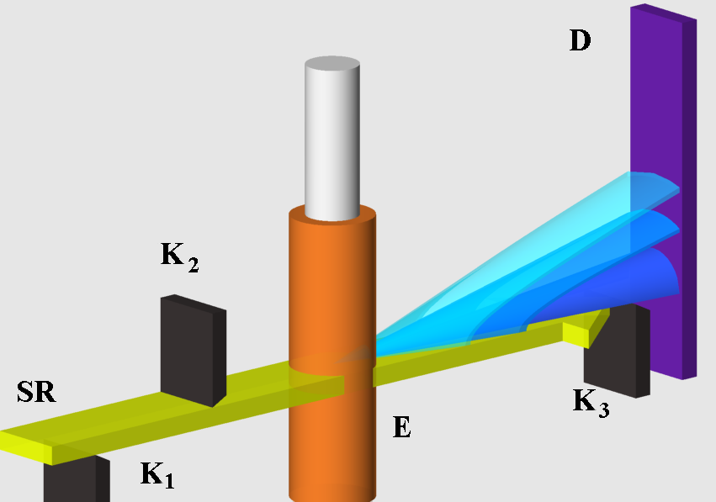
Fig.3. Schematic for SAXS signal registration

Since the detonation front is moving along the sample with a velocity of 7.5 km/s (for TATB with a density of 1,81 g/cm³), after the SR pulse repetition period Т = 0.5 μs the detector records another SAXS signal distribution (another frame), thus generating a sequence of SAXS signal distributions. Actually, this is X-ray diffraction cinema with the period Δt=0.5 μs and frame duration τ=1 ns.

The angular dependencies of SAXS signal at detonation of a TATB sample of 20 mm in diameter are shown in Fig.4. Here in the first two frames (B and C) a noticeable SAXS signal was registered, which practically vanished at the detonation front (frame D). It might be caused by the presence of noticible intercrystalline pores in the initial high explosive, which disappear when the explosive gets compressed by a powerful shock wave. Besides, even if condensed carbon particles appear in the zone of maximum compression of the explosive, the “contrast” value – the squared difference of the densities of the carbon particles and the explosive, (ρ–ρ₀)² – can turn out to be relatively small. The rest frames of Fig.5 demonstrate a smooth growth of the signal amplitude together with a change in the angular distribution of SAXS.
Fig.4. Dependence of the SAXS signal on time at TATB detonation.

At detonation of the high explosives under study (50/50 TNT/RDX mixture, TNT, and TATB), the dependence of SAXS signal on time is approximately the same but the integral signal amplitude (summed over all the channels of the detector) differs noticeably. That can be seen in Fig.5, where the moment t=0 corresponds to the detonation front passage. One can see that the highest integral SAXS signal is observed in the 50/50 TNT/RDX mixture and that of TNT and ТАТВ charges is distinctly smaller (by a factor of 1.5-2). That means that the scattering particles are of a lower density and most probably graphite-like.
Fig.5. Dependence of integral SAXS signal on time at detonation of TNT/RDX (50/50), TNT, and TATB

The average size of particles arising behind the detonation front was determined from experimental data with application of relations known from the SAXS theory [6,7]. Under the assumption of sphericity of these particles, the interval of the registered values of their diameter was determined subject to the parameters of the experimental facility and SR beam. The maximum registered angle is 2θ_{max} = 0.011 rad, and the radiation wavelength λ_{min}=0.041 nm corresponds to the energy Е_{max}=30 keV. Thus, the minimal size of registered particles is d_{min}=π/q_{max}=λ_{min}/(4θ_{max}) ∼2 nm. The minimum registered angle 2θ_{min}=4.4⋅10⁻⁴ rad is defined by the accuracy of positioning of blade K₃ (Fig. 1), which is about 0.2 mm. At λ_{max}=0.062 nm (Е=20 keV), the maximum particle size is d_{max}=π/q_{min}=λ_{max}/(4θ_{min}) ~70 nm.
Development of the average particle size in three experiments with TATB samples subject to calibration (Fig.2) is shown in Fig.6, where the moment t=0 corresponds to the detonation front passage. Nanoparticles of d=(2.2-2.3) nm are registered practically immediately after the detonation front. Then the particle size is increasing weakly and reaches d ∼ 2.6 nm by the moment t=4 μs. Fig. 7 presents, for comparison, similar data for a TNT/RDX (50/50) sample of 15 mm in diameter. Far larger growth of particle sizes is observed in this case: from the initial d=(2.5-2.8) nm to d∼ 4.6 nm.

Fig. 6. Nanoparticle size versus time at TATB detonation.
Fig. 7. Nanoparticle size versus time at TNT/RDX (50/50) detonation.

Thus no traces of nanodiamonds were registered at detonation of TATB samples of 20 mm in diameter. Even if there are such nanodiamonds, their size does not exceed 1 nm. The arising graphite-like particles are of d∼2.6 nm.

References
1. J.A. Viecelli, F.H. Ree. Carbon particle phase transformation kinetics in detonation waves. Journal of Applied Physics, Vol 88, Num 2, 2000, P. 683-690.

2. K.F.Grebenkin, M.V.Taranik, A.L.Zherebtsov. Slow energy release in detonation products of HMX-based explosives: computer modeling and experimental effects.// Zababakhin scientific talks, International Conference, Snezhinsk, Russia, 10-14 September 2007, p. 76

3. V.M. Titov, B.P. Tolochko, K.A. Ten, L.A. Lukyanchikov, E.R. Pruuel. Where and when are nanodiamonds formed under explosion? Diamond & Related Materials. V.16, Issue 12, 2007. P. 2009-2013.

4. K.A. Ten, V.M. Aulchenko, L.A. Lukianchikov, E.R. Pruuel, L.I. Shekhtman, B.P. Tolochko, I.L. Zhogin, V.V. Zhulanov. Application of introduced nano-diamonds for the study of carbon condensation during detonation of condensed explosives. Nuclear Instruments and Methods in Physics Research, ISSN 0168-9002, Section A, Vol. 603, Issue 1-2, 2009, pp. 102-104.

5. A. Aulchenko, V. Zhulanov, L. Shekhtman, B. Tolochko, I. Zhogin, O. Evdokov, K. Ten. One-dimensional detector for study of detonation processes with synchrotron radiation beam. Nuclear Instruments and Methods in Physics Research, Section A, 2005, Vol. 543, Issue 1, 1 May, P. 350-356.

6. A. Guinier, G. Fornet, C.B. Walfer, K.L. Yudovitch. Small-Angle Scattering of X-Ray. Wiley, N.Y. 1955.

7. L.A. Feigin, D.I. Svergun. Structure Analysis by Small-Angle X-Ray and Neutron Scattering. NY, Plenum Press. 1987. P.335.

Discussion
Laurence Fried, LLNL:
Have you performed experiments on explosives that do not form carbon, as a check that your signal is due to carbon?

Replay by E. Pruuel

Yes. We have performed such experiments. For rdx and petn samples SAXS signal was ten times smaller.

